**InterPlanetary File System** (**IPFS**)

• It is a protocol and peer-to-peer network for storing and sharing data in a distributed file system. • It uses content-addressing to uniquely identify each file in a global namespace connecting all computing devices.

• It allows users to host and receive content in a manner similar to BitTorrent. • It is built around a decentralized system of user-operators who hold a portion of the overall data, creating a resilient system of file storage and sharing.

• Any user in the network can serve a file by its content address.

• Other peers in the network can find and request that content from any node who has it using a distributed hash table (DHT).

**Official website**

*https://ipfs.io/*

**for more information**

*https://snapcraft.io/install/ipfs/ubuntu*

1) Commands to Install IPFS

*sudo apt-get update*

*sudo apt-get install snapd*

*sudo snap install ipfs*

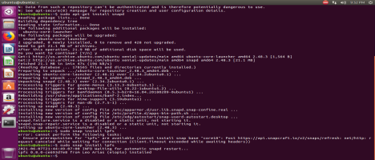

2) ipfs stores all its settings and internal data in a directory called *the repository.* Before using IPFS for the first time, need to initialize the repository.

*Ipfs init*

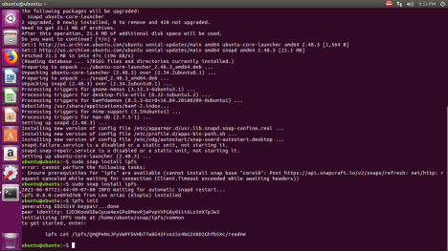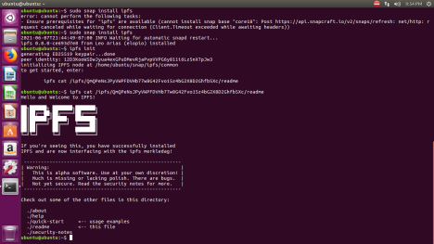

3) create demo.txt and write some content into it and add to the ipfs.

*vi demo.txt //write something, save and close*

*ipfs add demo.txt // add to the ipfs*

**

4) get the content of demo.txt by using hash.

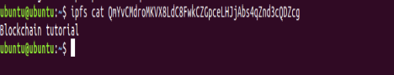

5) To add the directory to ipfs

*ipfs add -r .*

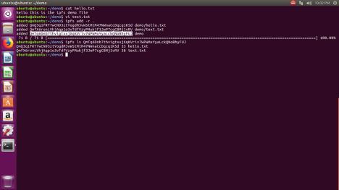

6) To join your node to the public network

*Ipfs daemon*

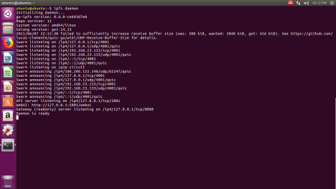

7) To know the peers

*swarm peers*

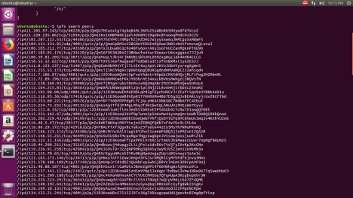

8) To know the details of particular peer

*Ipfs id <ID of peer>*

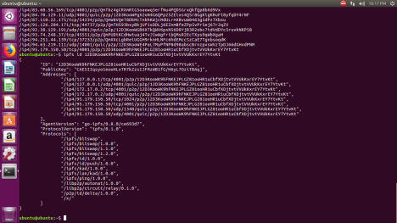

9) GUI available for IPFS

http://127.0.0.1:8080/ipfs

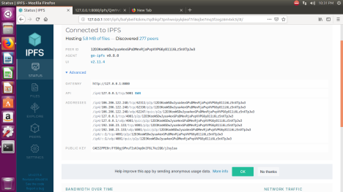

10) Drag and drop a file to ipfs add a file

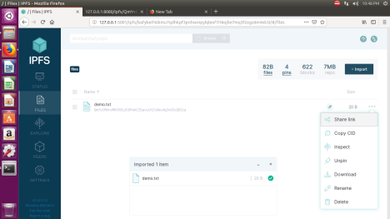

11) By using share link, get hash of the file.

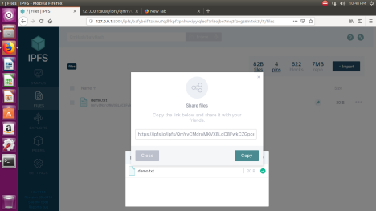

12) Copy n paste the link in any browser // it is available globally

